INSTALLATION OF PYTHON 3.9.8

|  |  |
| --- | --- |
| **Date** | 26 OCTOBER 2022 |
| **Team ID** | PNT2022TMID26841 |
| **Project Name** | Hazardous Area Monitoring for Industrial Plant powered by IoT |

Step 1: Type python in google and click on the first link



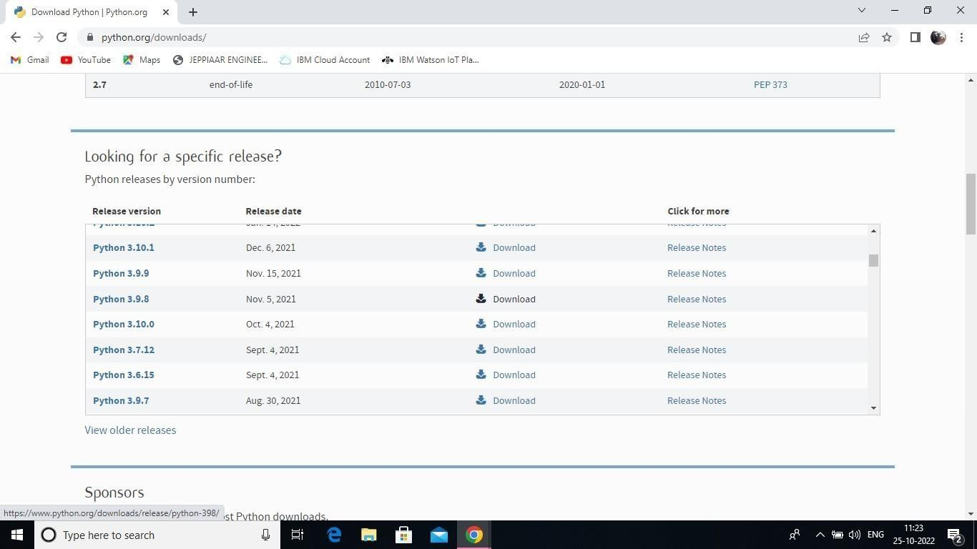

Step 3: Scroll down to reach Files and click on “Window installer (64 bit)

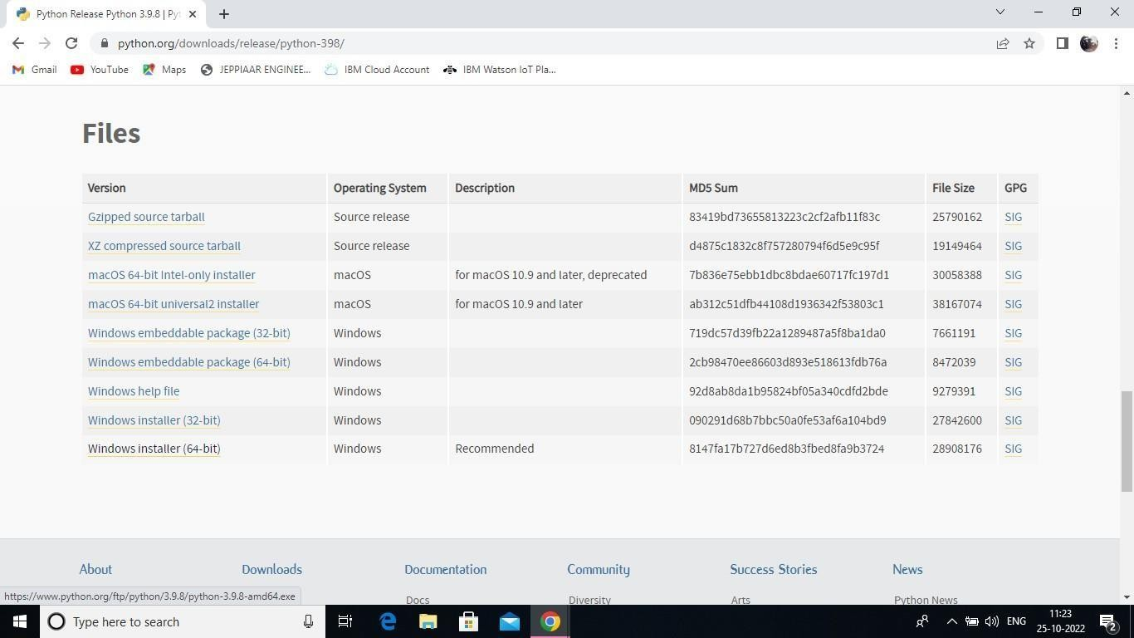

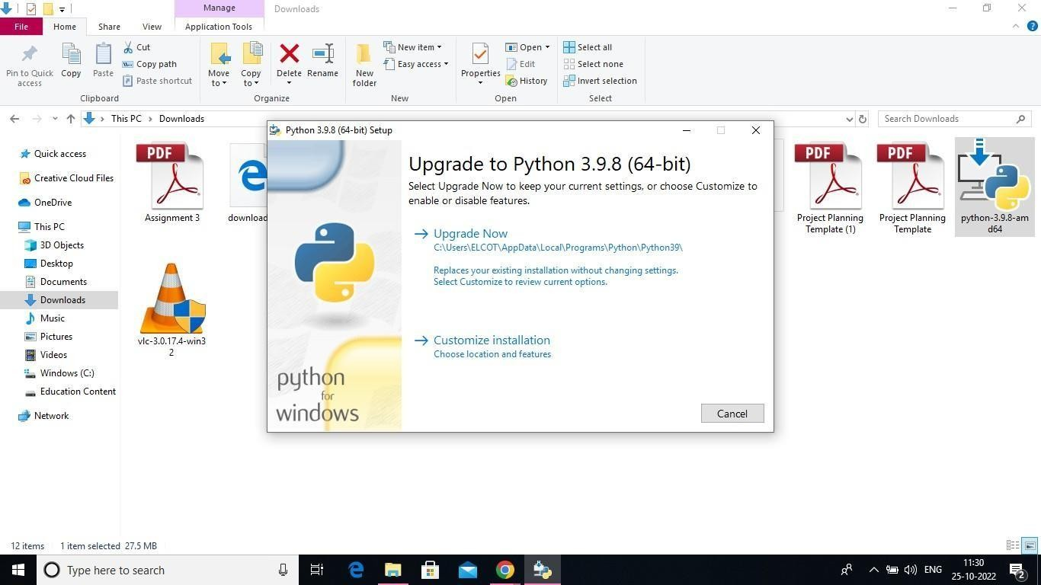

Step 5: Installation on progress

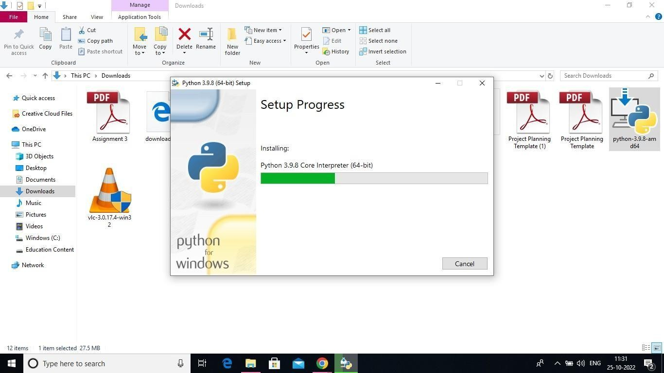

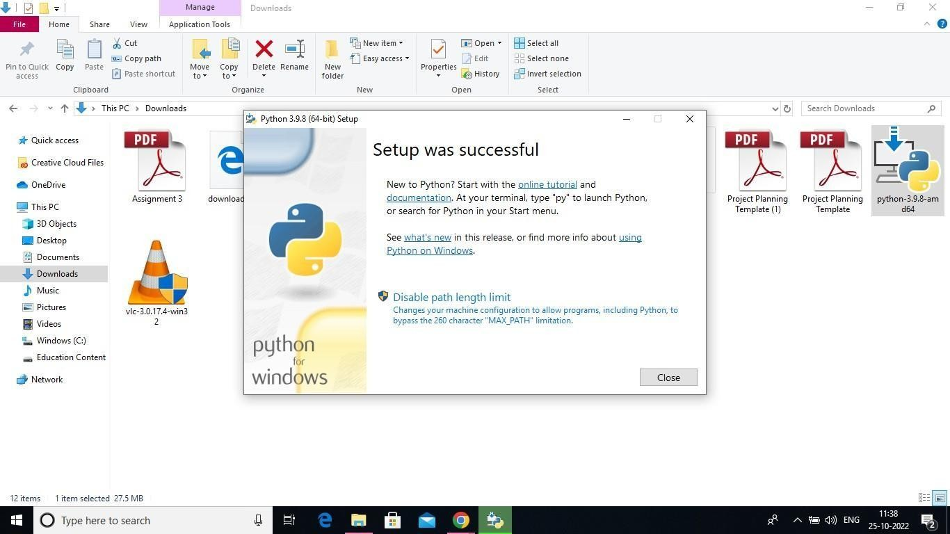

Step 7: Search IDLE

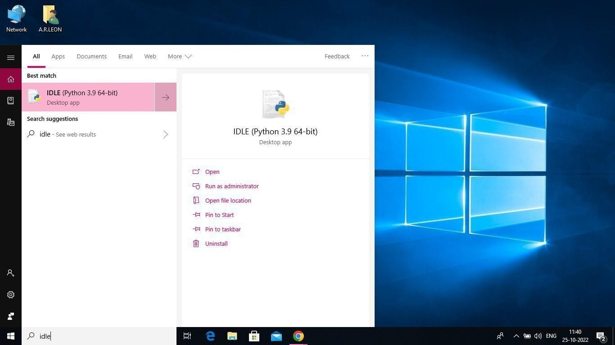

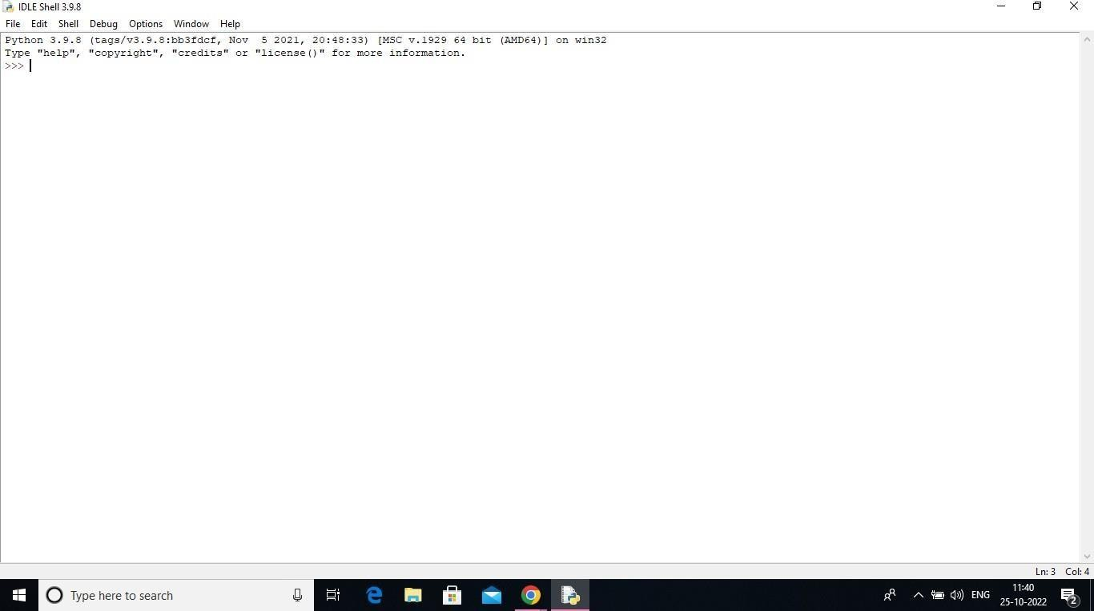

Step 9: Go to file and click on New File

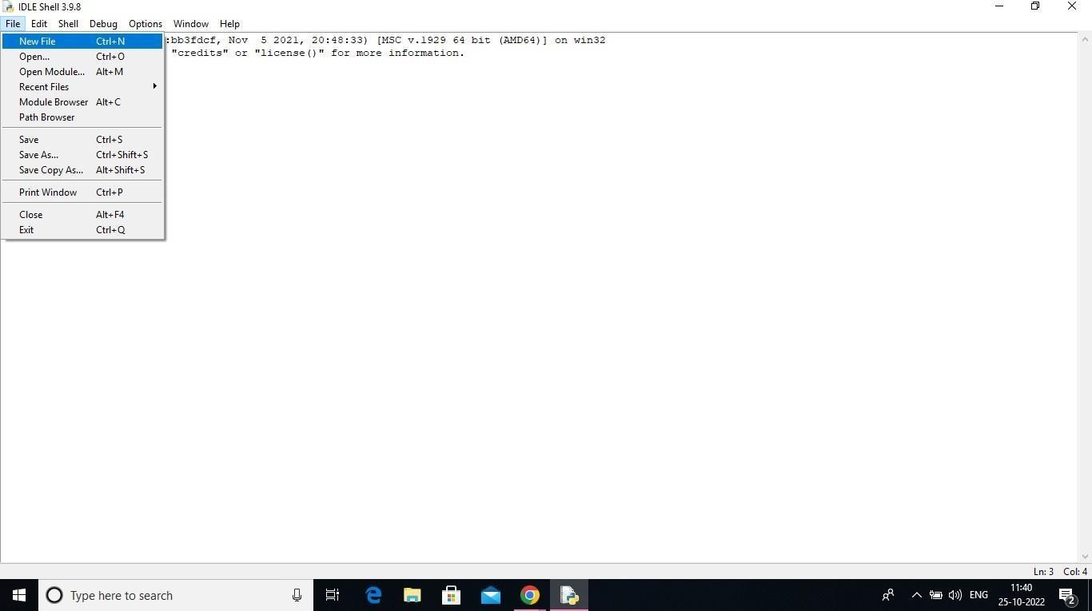

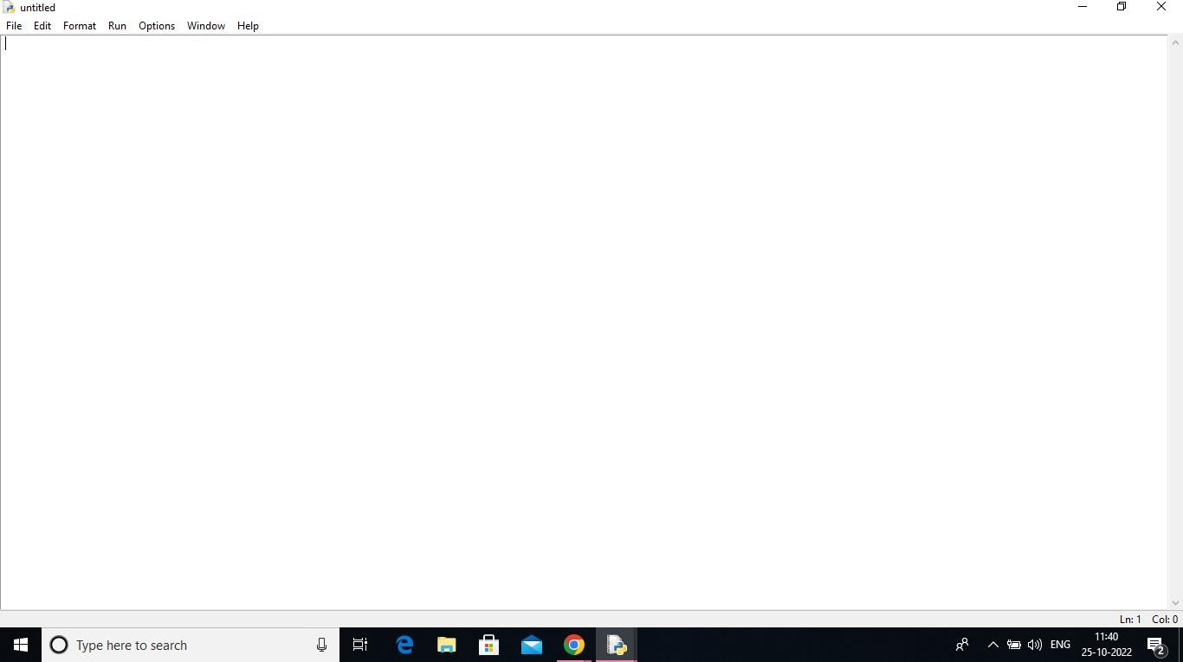

A Python 3.9.8 is installed successfully.